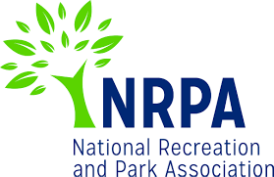
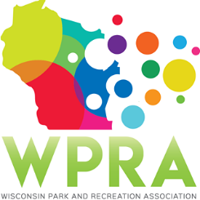
WPRA - Park Section

Friday, January 24, 2020
10:30 am
Online

Dial-in number (US): (425) 436-6318
Access code: 618492#
Online meeting ID: stinsonj
Join the online meeting: https://join.freeconferencecall.com/stinsonj

MEETING AGENDA

- Call meeting to order
- Roll call
- Review minutes from December 6, 2019

- Unfinished business
  - Spring Workshop- April 23 & 24, Middleton
    - Student price
    - Registration numbers
    - Promote!
  - Conference Sessions
    - Identify most desirable sessions from December’s list
    - Speaker solicitation deadline March 2nd
  - One Day Summer Parks Tour – Wausau/Marathon County

- New Business
  - Park Design Awards

- Reports
  - Chair – Joleen Stinson
  - Chair Elect – Seth Westberg
  - Past Chair – Dan Wick
  - Secretary/Treasurer – Stephanie Schlag
  - Region 1 – Steve Peterson
  - Region 2 – Vicky Redlin
  - Region 3 – Ethan Lee
  - Region 4 – Eddie Santiago
  - Representative at Large – John Lofgren
  - Representative at Large – Patrick Groom
  - State Park/DNR – Kathy Gruentzel
  - Urban Forestry Council – Tony Nowak
  - WPRA – Stephanie Schlag

- Adjourn

Next Meeting: Tuesday, February 19 at UW - Stevens Point, 10 AM (lunch at noon open to all meeting attendees with WPRA committee meetings to follow at 1 PM)

