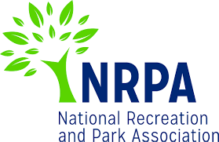
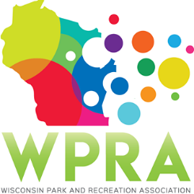
WPRA - Park Section

Friday, December 6th, 2019
10:30 am
DeForest’s Fireman’s Park Community Room
Suggested address for mapping: 120 S Stevenson St
(which is Village Hall’s address, just across the street)

MEETING AGENDA

- Call meeting to order
- Roll call
- Review minutes from October 25th

- Unfinished business
  - Spring Workshop 2020

- New Business
  - 2020 WPRA Conference
    - Session topics & speakers: please bring 3-4 session topic or speaker ideas
    - Review 2019 conference survey results
  - Approve Seth Westberg as 2020 Chair Elect
  - One Day Summer Parks Tour in 2020
  - Spring Workshop 2021 – Location
  - Professional and Young Professional of the Year Awards
  - Park Design Awards

- Reports
  - Chair – Dan Wick
  - Chair Elect – Adam Breest
  - Past Chair – Dan Kremer
  - Secretary/Treasurer – Vacant
  - Region 1 – Steve Peterson
  - Region 2 – Vicky Redlin
  - Region 3 – Joleen Stinson
  - Region 4 – Erin Cross
  - Representative at Large – Marcus Aumann
  - Representative at Large – Patrick Groom
  - State Park/DNR – Kathy Gruentzel
  - Urban Forestry Council – Tony Nowak
  - WPRA – Jake Anderson

- Adjourn

Next Meeting: Friday, January 24, 2020, 10:30 AM, online

