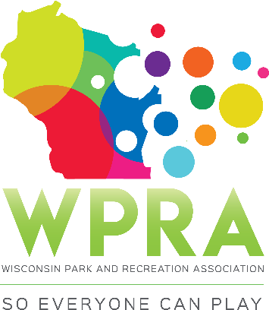

REC SECTION MEETING AGENDA
April 10, 2019
Good Company 6:30pm

- CALL MEETING TO ORDER

- ROLL CALL:
Greg Lamping; Chair ___ Tyler Ketterhagen; Region 1 ___
Tony King; Past-Chair ___ Adrienne Lacy; Region 2 ___
Troy Clarke; Chair-Elect ___ Ben Dayton; Region 3 ___
Megan James, Sec/Treas ___ Maggie Anderson; Region 4 ___
Erin Russell, TR ___ Jenni Kilpatrick, WPRA ___

- APPROVE AGENDA

- APPROVE March MINUTES

- OLD BUSINESS
  - Spring Workshop – Finalize everything for tomorrow. i.e, Moderators, equipment, “Pub Crawl”
- NEW BUSINESS
  - Rec Section Awards for Conference
  - WPRA:USA Archery Grant
  - Community Based Recreation & Leisure Service
  - Nomination for Vacant Board Positions: call for nominations

- COMMITTEE REPORTS
- SPRING WORKSHOP 2019
- CONFERENCE WPRA
- REC AWARDS
- YOUTH LEADERSHIP

- OFFICER REPORTS
- CHAIR REPORT (Greg)
- PAST-CHAIR (Tony)
- CHAIR-ELECT (Troy)
- SECRETARY/TREASURER (Megan)

- REGION/WPRA REPORTS:
- REGION 1 (Tyler)
- REGION 2 (Adrienne)
- REGION 3 (Ben)
- REGION 4 (Maggie)
- WPRA (Megan)

- ANNOUNCEMENTS/OTHER MATTERS

- ADJOURNMENT

