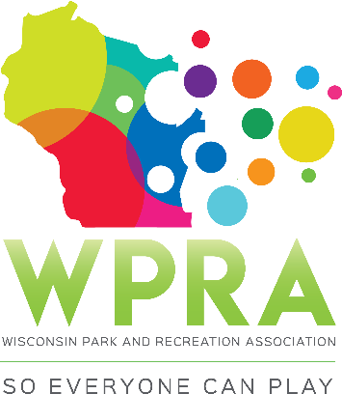

REC SECTION MEETING AGENDA
May 9, 2019
10:00 am

- CALL MEETING TO ORDER

- ROLL CALL:
Greg Lamping; Chair Present Tyler Ketterhagen; Region 1 Absent
Tony King; Past-Chair Present Ben Dayton; Region 3 Present
Megan James, Sec/Treas Present Maggie Anderson; Region 4 Absent
Erin Russell; TR Present Dan Zeroth; CBRSD Present
- APPROVE AGENDA

Adrienne Lacey motioned, and the motion was seconded by Tony King

- APPROVE April MINUTES

There was not an April meeting due to weather, so there were no minutes to approve.

- OLD BUSINESS
  - Community Based Recreation & Leisure Service
Welcome Dan to Recreation Section, who will be chair of sub-committee this year. Goal of Community Based Recreation and Leisure Service is to have their own section in the future.

- NEW BUSINESS
  - Rec Section Awards for Conference
- WPRA deadline is 6/28 for their awards.
- We will keep ours same as years past, shooting for June deadline
- Greg will send award entries and guidelines forms out to Section
- For 2019, we will have one winner per category (as opposed to multiple winners in years past)

  - WPRA:USA Archery Grant
- Decision was made to not further explore the partnership opportunity, but rather just make members aware of the grant opportunity.
- It was unclear what WPRA will really benefit from having the partnership, which helped to make this decision to not become an actual partner.

  - Nomination for Vacant Board Positions: call for nominations
- Vacant board positions for next year are Region 1 and 3 representatives and chair-elect.
- Greg has asked that Region reps try to come up with some nominees

  - Community Based Recreation & Leisure Service (Sub Committee Members)

- Dan is chair, but need a couple more members to help Dan with sub-committee.
- Ben will join Dan on sub-committee

- COMMITTEE REPORTS
- SPRING WORKSHOP 2019 – Feedback from attendees was that it went overall went really well and had great speakers. Enjoyed combining park and recreation sessions as it seemed to go very well.

  - Recap (Financials, #participants)
- $4500 revenue, which brought profit to $1910.86 after all expenses
- 53 participants registered, but only 41 showed up due to the April snowstorm

  - 2020 Spring Workshop (Middleton)

- No date set yet, as there may be a discussion coming up at the next WPRA board meeting on whether it makes sense to continue offering Spring Workshop due to low attendance in recent years. Hopefully Megan will be able to give more insight on this topic after the next WPRA Board meeting next week.

- CONFERENCE WPRA
  - New Speaker
- Kirsten Barnes backed out, so we are now having Jed and Roz. They were a top runner when we ranked all speakers, but due to budget we opted to have Kirsten Barnes rather than Jed and Roz. So this works out well as we are still confident in a good speaker taking the sessions we had scheduled Kirsten for.

- REC AWARDS
  - Deadline for 2020 format of awards is 1st Friday in May in hopes to push for more nominees in the future
  - Concerns regarding this deadline as that is a lot to push onto new elects in the beginning of the year (Spring Workshop finalizing, Conference speakers for current year, and now awards all before May)

- YOUTH LEADERSHIP
- No updates

- OFFICER REPORTS
- CHAIR REPORT (Greg)
- Other than giving feedback on Spring Workshop above, no new updates. Will send out awards nominals and awards forms.

- PAST-CHAIR (Tony)
- Other than giving feedback on Spring Workshop above, no new updates.

- CHAIR-ELECT (Troy)
- No update

- SECRETARY/TREASURER (Megan)

- Looking for topics to do on next Impact Magazine due in July, but wanted to get a head start
    - Possible topics suggested included highlighting speakers at conference, interview 2019 Professional of the Year to give some insight.

- REGION/WPRA REPORTS:
- REGION 1 (Tyler)
- No report

- REGION 2 (Adrienne)
- No report

- REGION 3 (Ben)
- No report

- REGION 4 (Maggie)
- No report

- CBRSD (Dan)
- No report

- WPRA (Megan)

- Next meeting 5/14, so will have more to update on after that.

- ANNOUNCEMENTS/OTHER MATTERS
- 8/8 next meeting
- Megan will more than likely be on maternity leave as of this date as her baby is due 8/8. Tony mentioned being able to step in at WPRA Board meetings if needed.

- ADJOURNMENT
- Motioned: Erin Russell, Seconded: Tony King

