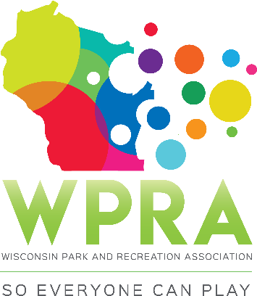

REC SECTION MEETING AGENDA
October 10th, 2019
10:30 am

- CALL MEETING TO ORDER

- ROLL CALL:
Greg Lamping; Chair ___ Tyler Ketterhagen; Region 1 ___
Tony King; Past-Chair ___ Adrienne Lacy; Region 2 ___
Troy Clarke; Chair-Elect ___ Ben Dayton; Region 3 ___
Megan James, Sec/Treas ___ Maggie Anderson; Region 4 ___
Erin Russell; TR ___ Dan Zeroth; CBRSD ___

- APPROVAL OF SEPTEMBER MINUTES

- APPROVE AGENDA

- OLD BUSINESS
- 2020-2021 Budget
- Strategic Planning
- Rec Award Packet
- Playground Workshop

- NEW BUSINESS
- 2020-2021 Budget Breakdown
  - Fun Run/ Scavenger Hunt
  - Playground Workshop (speaker rate)
  - Conference Speaker Budget (2021)
- Quarterly in Person Meetings 2020
- Aquatic/Rec Section Awards (Joint Categories)
- Professional of the Year Format (
- Rec Section Election Results

- COMMITTEE REPORTS
- SPRING WORKSHOP 2020 (Middleton)
- New Planning Structure
- Schedule at a Glance
- Ideas of Topics

- CONFERENCE
- Moderator Schedule
- November Meeting Location
- To Do List

- REC AWARDS
- Young & Professional of Year Nominations
- To Do List

- PLAYGROUND WORKSHOPS
  - Dates/Locations 2020

- OFFICER REPORTS
- CHAIR REPORT (Greg)
- PAST-CHAIR (Tony)
- CHAIR-ELECT (Troy)
- SECRETARY/TREASURER (Megan)

- REGION/WPRA REPORTS:
- REGION 1 (Tyler)
- REGION 2 (Adrienne)
- REGION 3 (Ben)
- REGION 4 (Maggie)
- CBRSD (Dan)
- WPRA (Megan)

- ANNOUNCEMENTS/OTHER MATTERS

- ADJOURNMENT

