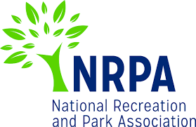
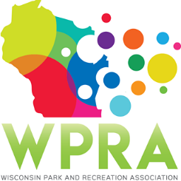
WPRA - Park Section

Friday, March 22, 2019
10:30 am
Online

MEETING AGENDA

- Call meeting to order
- Roll call
- Review minutes from 2/22/2019

- Unfinished business
  - 2019 Spring Workshop
    - Registration Numbers as of Friday, March 15 – 41 attendees
    - Who will be attending
      - Registration Table
        - Dan W. stated that he would work the registration table Thursday morning prior to the first session beginning
      - Moderators
Dan W. will assign section members to do the moderating
  - 2019 Annual Conference
    - Schedule at a Glance
Dan K presented the schedule at a glance for the section to see. Dan K. thank everyone for helping gather all of the speakers
    - Speaker Contracts
      - Dan K stated all contracts have been signed and turned in – reminders and follow up calls will need to be placed in the fall. Dan K. will produce a moderator schedule in September.

- New Business
  - Park design awards procedural discussion
    - Marcus and Dan will be working with Matt this year as the two of them transition into taking it over. Section had discussion on the section process of the Park Design awards. Park section will be working with the section to review and select the Design Award winners going forward.
  - Spring Workshop 2020 – Middleton
    - Adam is working with a couple different venues in Middleton and will be reporting back to the Section at our May meeting on dates and location
  - Spring Workshop 2021 – Location
    - Section discussed where we would like to see the 2021 Spring Workshop. Region 4 was the area that the Park Section would like to focus on
  - Professional and Young Professional of the Year
Discussion held on trying to get this in unison through WPRA similar to how it was handled in 2018.

- Reports
  - Chair – Dan Wick – No Report
  - Chair Elect – Adam Breest – No Report
  - Past Chair – Dan Kremer – No Report
  - Secretary/Treasurer – Denise Larson – No Report
  - Region 1 – Steve Peterson – No Report
  - Region 2 – Vicky Redlin – No Report
  - Region 3 – Joleen Stinson – No Report
  - Region 4 – Erin Cross – No Report
  - Representative at Large – Marcus Aumann – No Report
  - Representative at Large – Patrick Groom – No Report
  - State Park/DNR – Kathy Gruentzel – No Report
  - Urban Forestry Council – Tony Nowak – Tony recapped the Urban Forestry Annual Meeting that had taken place in Green Bay
  - WPRA – Denise Larson – No Report

- Adjourn

Next Meeting: Friday, May 24, 2019 – Online

