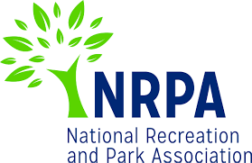
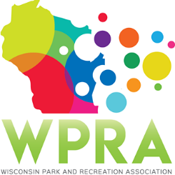
WPRA - Park Section

Thursday, September 12, 2019
10:00 am
Online

MEETING AGENDA

- Call meeting to order @ 10:03 am
- Roll call Present Dan Wick, Adam Breest, Dan Kremer, Vicky Redlin, Joleen Stinson, Erin Cross, Marcus Aumann, Kathy Gruentzel, Jennifer and Sandy from WPRA
- Review minutes from 5/24/2019
Motion by Marcus and second by Joleen for approval. Motion carried

- Unfinished business
  - 2019 Annual Conference
    - Schedule at a Glance
        - Dan Kremer will send out the moderator schedule with updates to the section
        - Dan Wick and Joleen Stinson each bring projector
    - Speaker Contracts
        - Section members must contact their speakers and confirm their room assignment and speaking time for the fall conference.
        - WPRA office to send out confirmation information for hotel rooms to the entire park section
  - Spring Workshop 2020
        - Middleton the location for 2020; Adam asked for feedback for topics and set up
        - Kathy stated hands on training has been the draw
        - School district topic mentioned
        - Hands on maintenance training for maintenance staff considered
        - Wick started discussion about if spring workshop should continue, numbers have dropped. Discussion followed regarding changes to increase numbers. Region meetings have changed format and may affect spring workshop.
- New Business
  - Spring Workshop 2021 – Location
        - Discussion on pricing for one day and training activities presented
        - Discussion on future location; will be selected about one year in advance
        - Lacrosse, Milwaukee, Marinette presented. Location may also be based on cool projects that are winning recent park section awards.
        - Committee decided to focus on 2020 spring workshop and make it the best possible and then evaluate 2021.
  - Professional and Young Professional of the Year
        - 1 YP nominated; 2 POF nominated
  - Park Design Awards
        - Matt Amundson coordinating; Kremer and Amuann to coordinate with him
  - Appointment of Kathy Gruentzel as State Park/DNR Rep
        - Motion by Kremer, second by Redlin to approve appointment. Motion carried

- Reports
  - Chair – Dan Wick
    - Strategic plan by WPRA very positive
    - New project 2020 is professional development committee creating speaker database
    - Elections currently going on, please vote
    - Section awards are due tomorrow
    - WPRA working on streamlining the awards
  - Chair Elect – Adam Breest
    - Attended strategic plan
    - Working on spring workshop as priority

  - Past Chair – Dan Kremer – no report
  - Secretary/Treasurer – Vacant
  - Region 1 – Steve Peterson
  - Region 2 – Vicky Redlin Meeting next Thursday @ Winnebago County, algae presentation
  - Region 3 – Joleen Stinson Meet tomorrow in Monona, Cheryl from DNR presenting grant info
  - Region 4 – Erin Cross Met at end of August, conference items being finalized
  - Representative at Large – Marcus Aumann No report
  - Representative at Large – Patrick Groom
  - State Park/DNR – Kathy Gruentzel New reservation system, changing policies for sites; has been challenging to implement.
  - Urban Forestry Council – Tony Nowak
  - WPRA – Jennifer - Be ready for bylaws talk at fall general meeting. Will be helping each section have more visibility next year for the publications. Budget for section due by October

- Adjourn
Motion Vicky; second Erin. Meeting adjourned at 10:59 am.

Next Meeting: Friday, October 25, 2019 @ 10:30 am – Online

