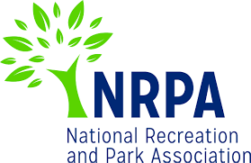
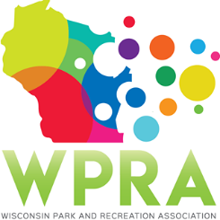
WPRA - Park Section

Friday, May 24, 2019
10:30 am
Online

MEETING AGENDA

- Call meeting to order
- Roll call – Dan Wick, Dan Kremer, Marcus Aumann, Adam Breest, Joleen Stinson, Erin Cross and Vicky Redlin. Tony Nowak, Kathy Gruentzel and Patrick Groom were excused
- Review minutes from 3/22/2019
Motion to approve by Joleen, second by Marcus; motion passed unanimously

- Unfinished business
  - 2019 Spring Workshop Recap – Made a profit
  - 2019 Annual Conference
    - Schedule at a Glance – All set
    - Speaker Contracts – All set
- moderator schedule to be distributed by Dan Kremer before end of June.

- New Business
  - Discussion on continuing Spring Workshops – Dan Wick stated he spoke with Chad Dalman and others at the workshop about the long term future and asked the board for thoughts. Joleen stated she believes the training opportunity is very beneficial to have outside of the fall conference. Marcus stated he believes there is a lot of time spent on it and low attendance is challenging. Vicky stated the section needs to do something in addition to the fall conference. Erin Cross stated a one day set up would be easier for her to attend.

Discussion followed on future workshop set up and fee structure. Dan Wick to check with Chad Dallman and Jake Anderson and send something out to the park section members.

  - Spring Workshop 2020 – Middleton – Current dates are April 9 and 10 but Easter is on April 12; hotel is not available the week prior or following. April 23-24 is available and March 26 and 27. $300 total for two meeting spaces and lunch area. $1,500 minimum must be spent for lunch. Room rates $82 single/$129 double @ Marriott West.

Motion by Vicky to move spring workshop to week of April 21st; second by Wick. Motion passed unanimously
  - Spring Workshop 2021 – Location – No location currently, targeting region 4
  - Professional and Young Professional of the Year – Adam stated YPN section considering condensing down the three section awards down into one young professional and professional of the year award. Idea being considered for 2020. No objections by park section but would like to see more information.

- Reports
  - Chair – Dan Wick – no report
  - Chair Elect – Adam Breest – no report
  - Past Chair – Dan Kremer – no report
  - Secretary/Treasurer – Denise Larson - Retired
  - Region 1 – Steve Peterson – not present
  - Region 2 – Vicky Redlin – no report
  - Region 3 – Joleen Stinson – no report but question about mosquitoes spraying
  - Region 4 – Erin Cross – No report
  - Representative at Large – Marcus Aumann – no report
  - Representative at Large – Patrick Groom
  - State Park/DNR – Kathy Gruentzel
  - Urban Forestry Council – Tony Nowak
  - WPRA – Denise Larson

- Adjourned @ 11:22 am

Next Meeting: Friday, August 23, 2019 – Online

